Meghna R
24BTRCL120
AIML-B

Exercise-1

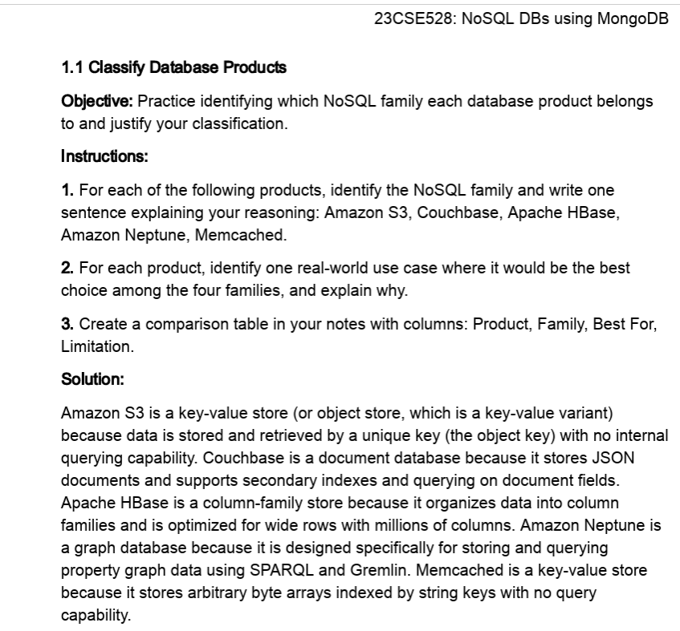
Input:
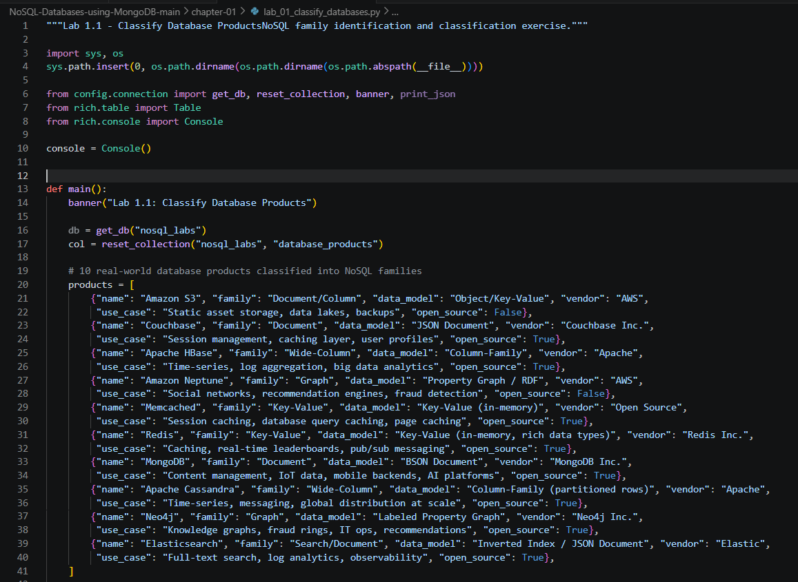
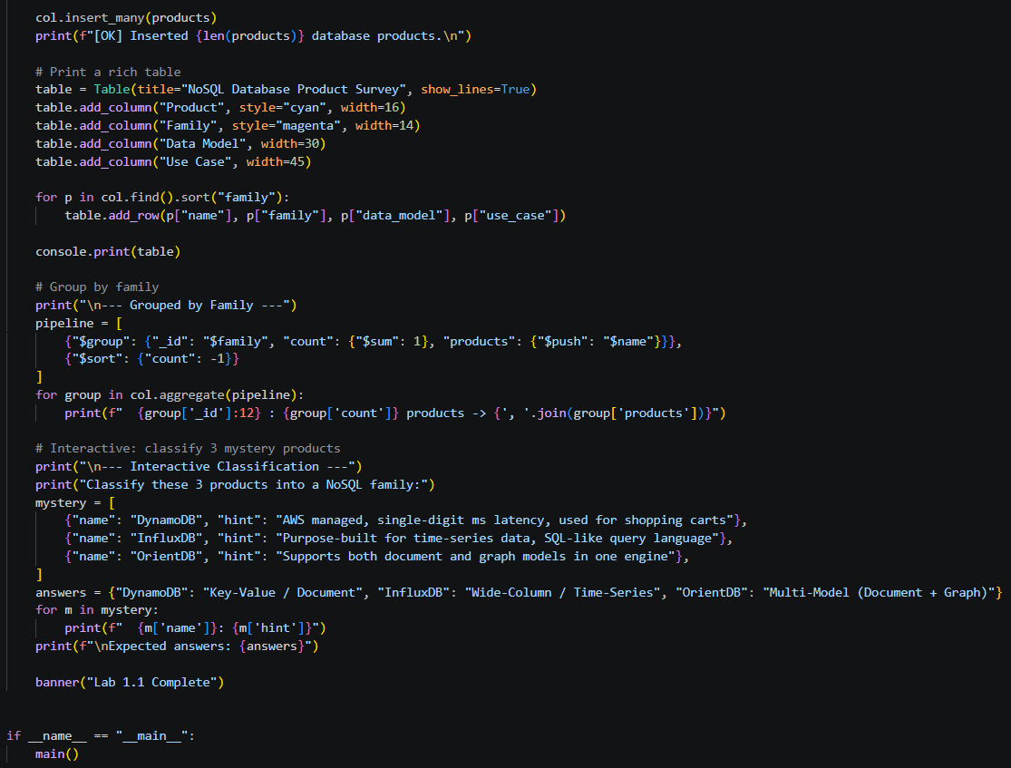

Output:
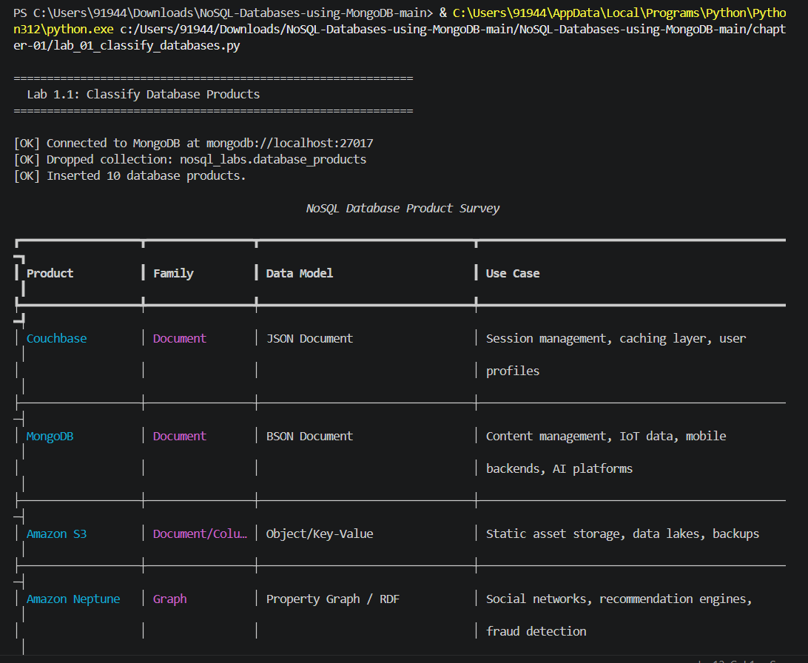
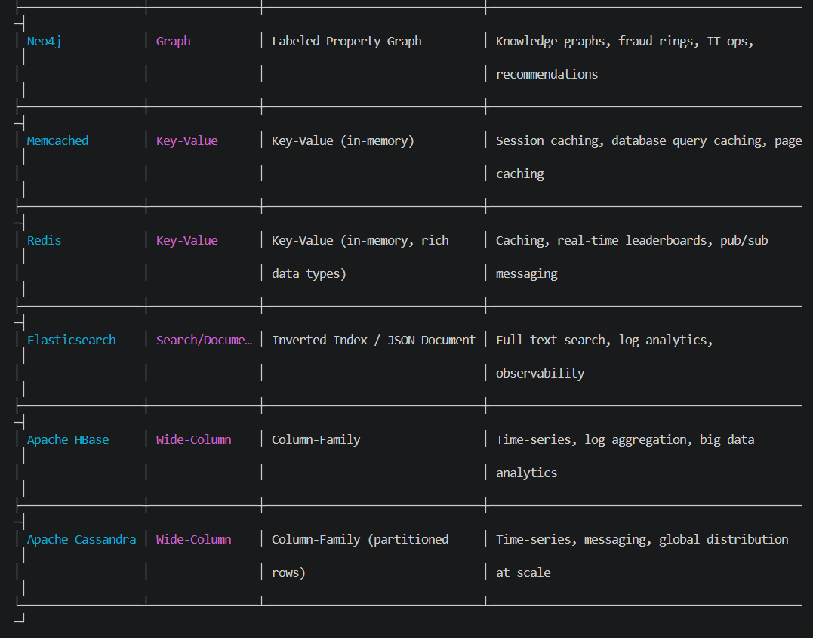
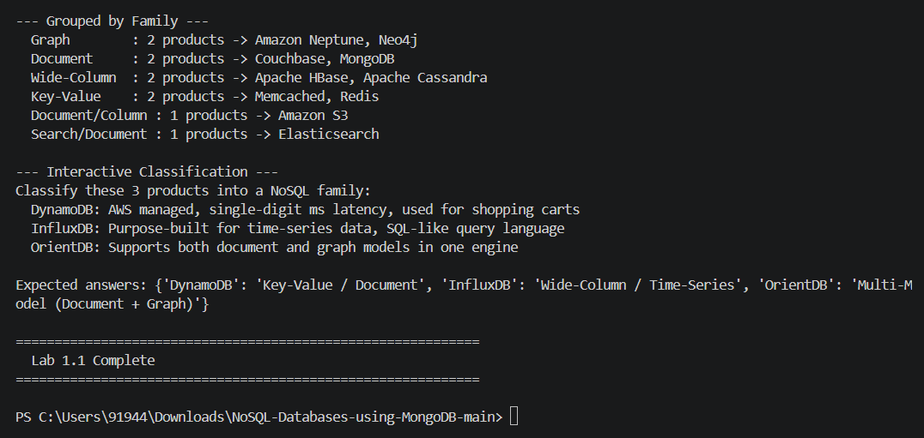
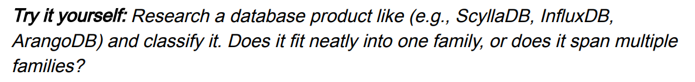

Solution:

Database Product: ArangoDB

Classification: ArangoDB is a multi-model NoSQL database. It supports document, key-value, and graph data models in a single database system.
It does not fit neatly into only one NoSQL family because it can handle multiple types of data models. This makes it useful for applications where documents, key-value data, and relationships need to be managed together.

Real-world use case
ArangoDB can be used in a social networking application. User profiles can be stored as documents, user IDs can be accessed as key-value data, and relationships between users can be represented using a graph.

Comparison Table
Product | Family | Best For | Limitation
ArangoDB | Multi-model: Document, Key-Value, Graph | Applications requiring multiple data models | More complex than using a single-model database

Input:

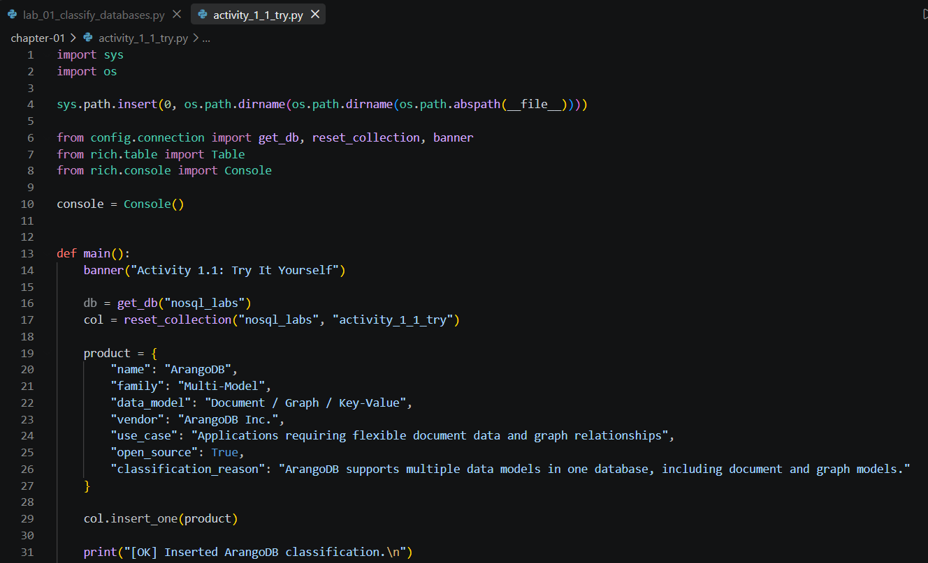
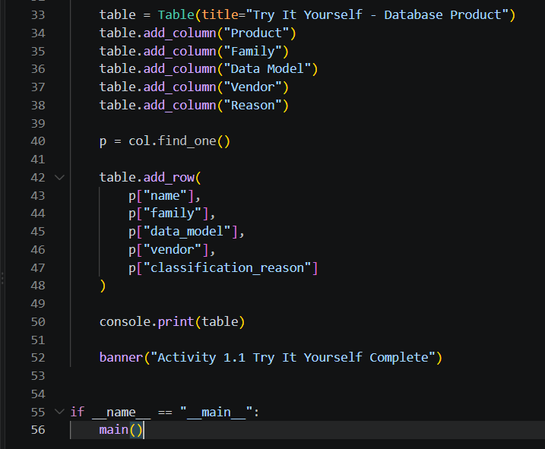

Output:
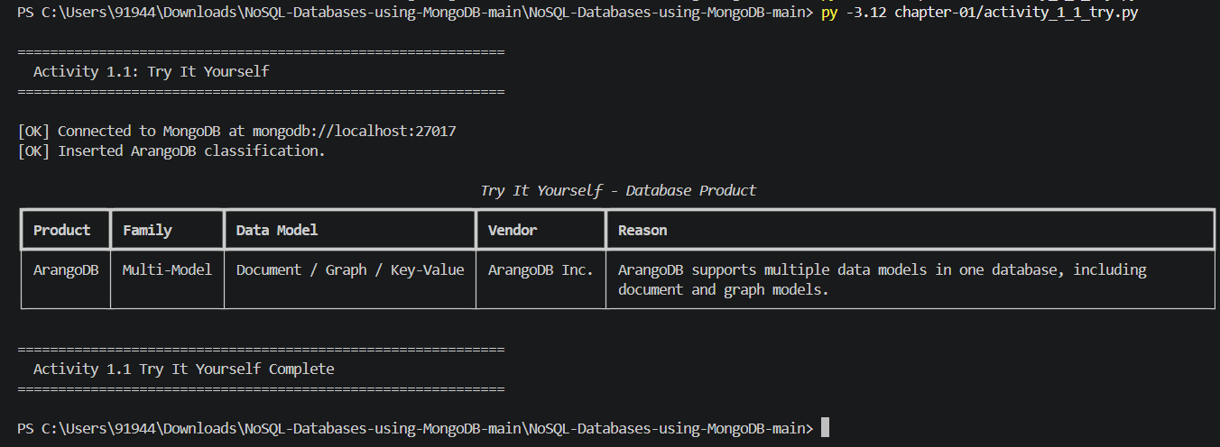
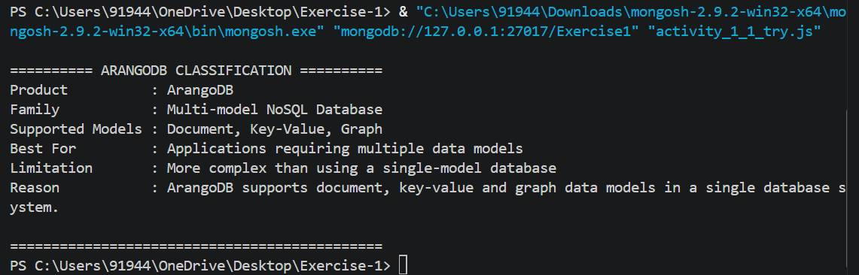
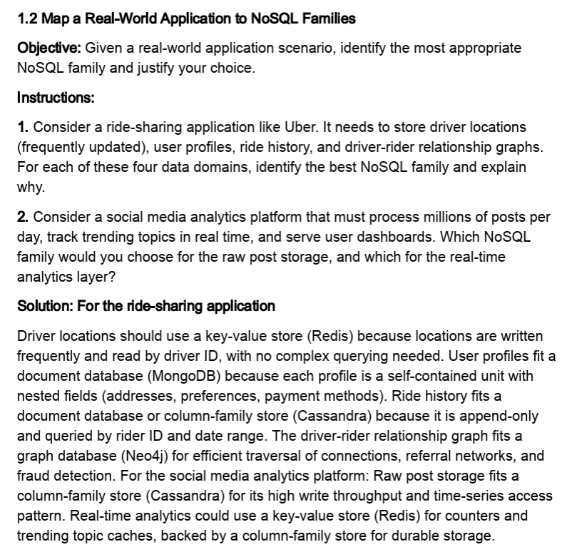

Input:
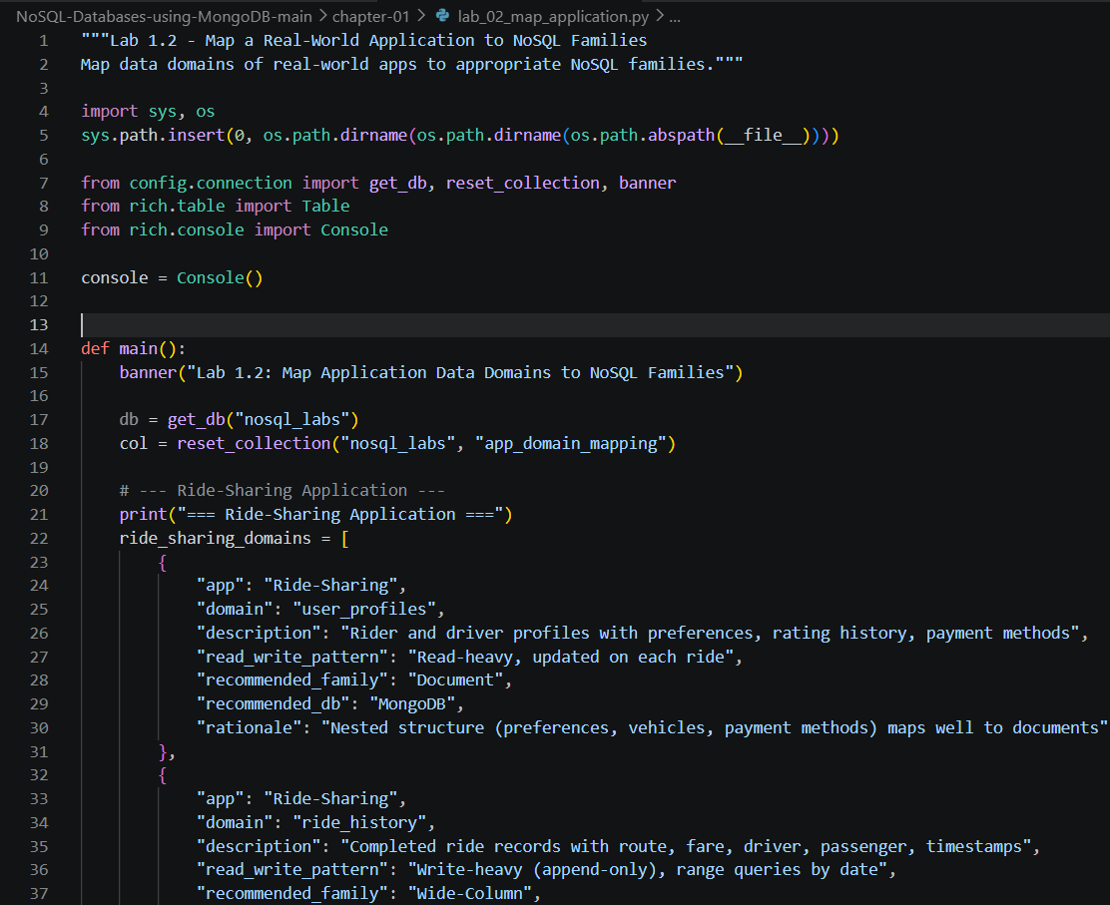
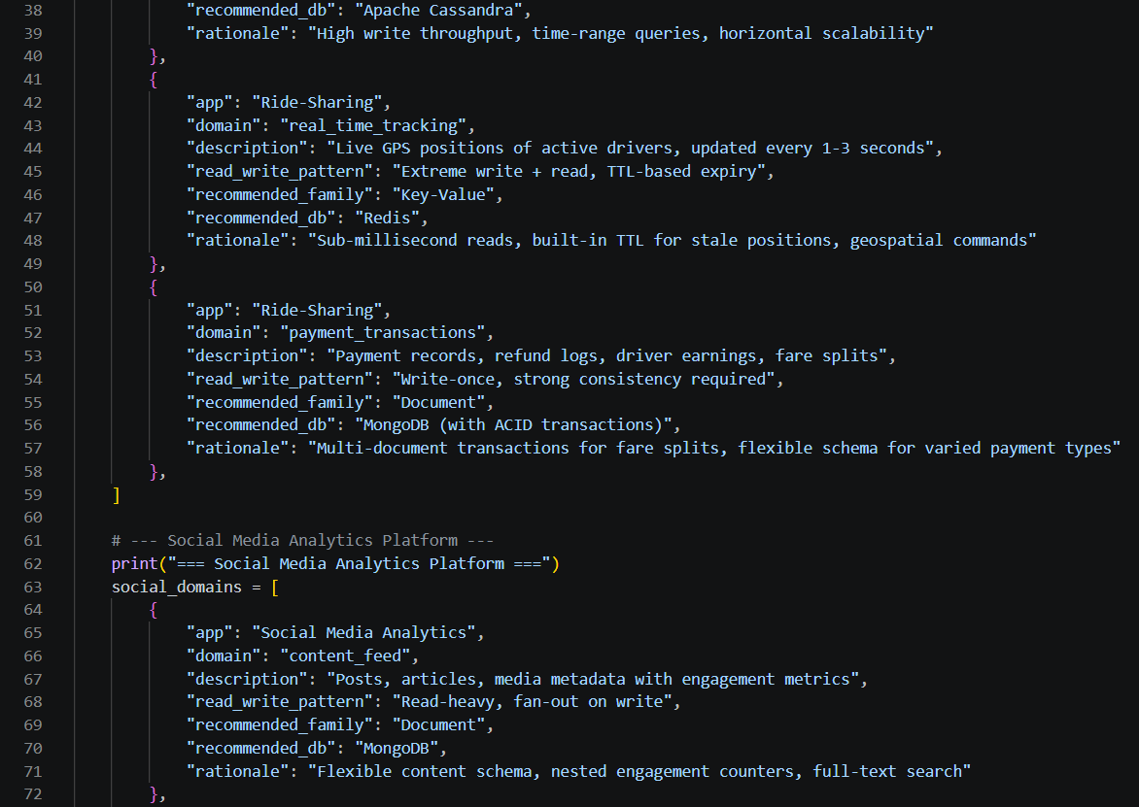
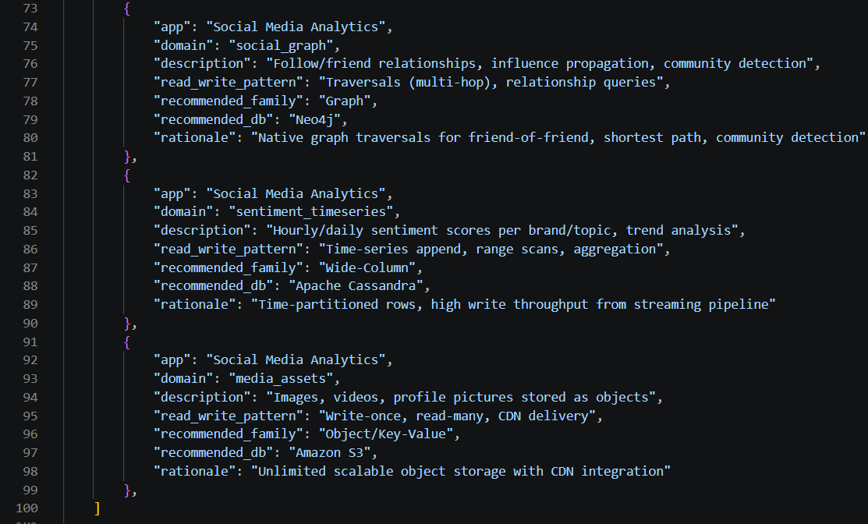
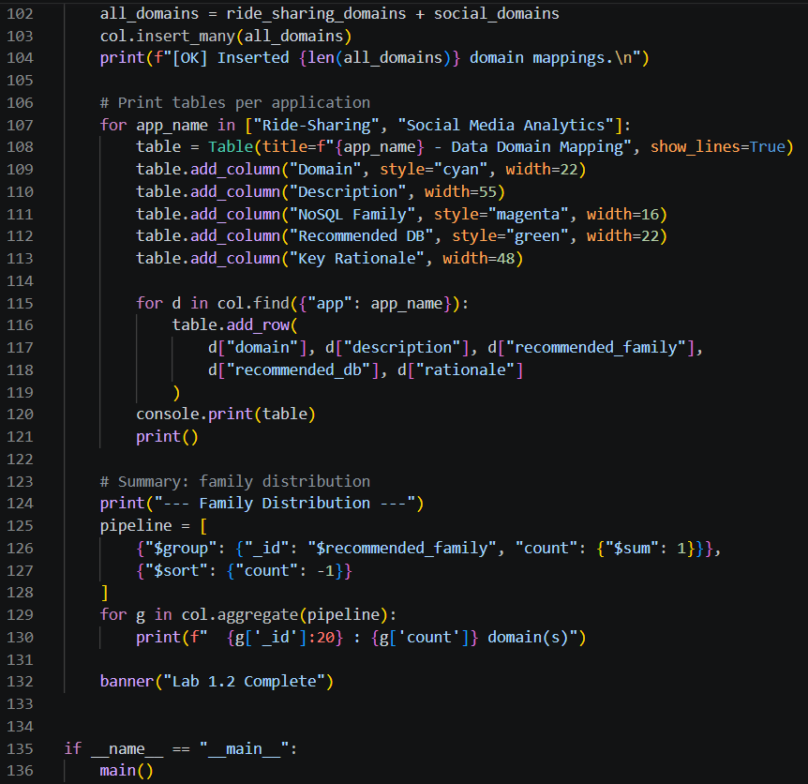

Output:
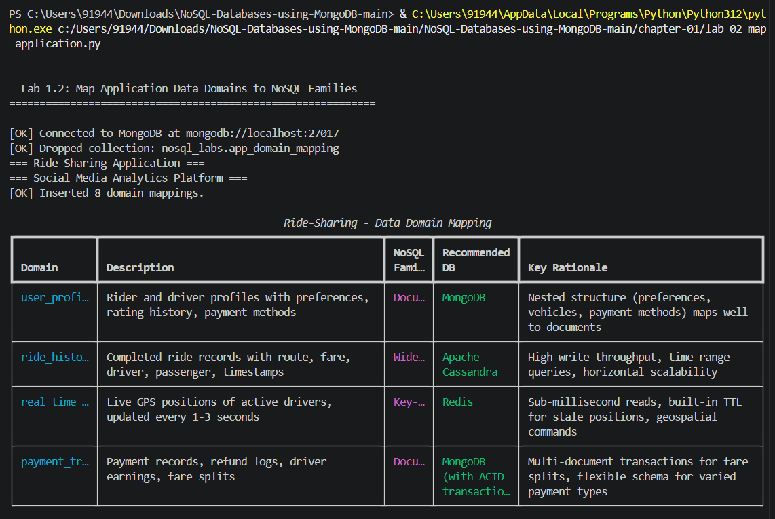
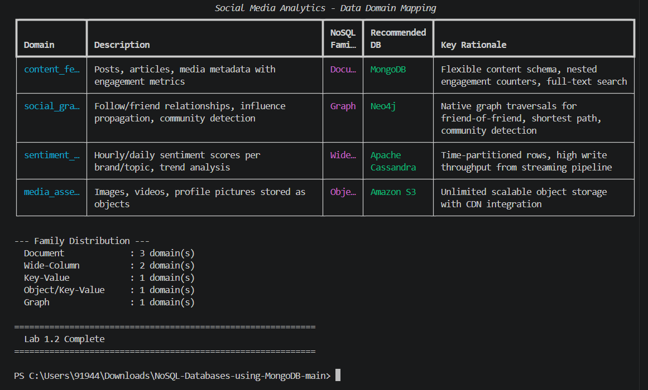

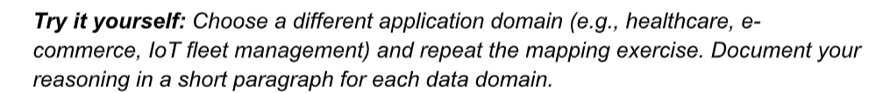
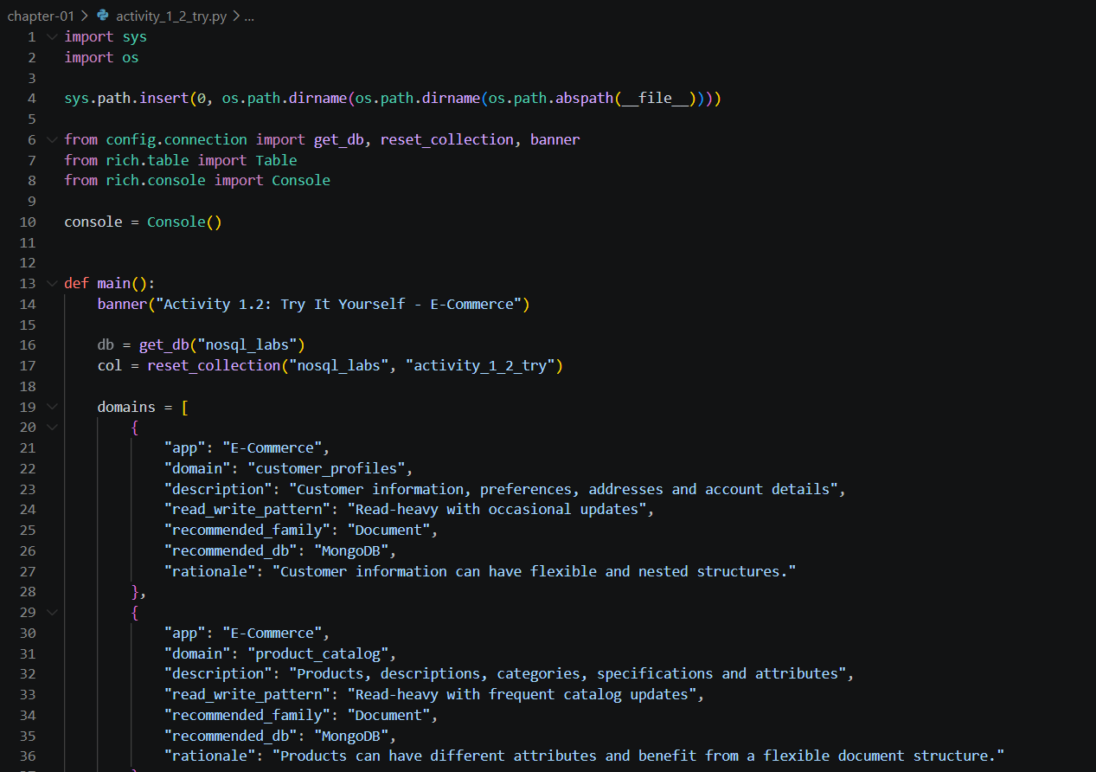
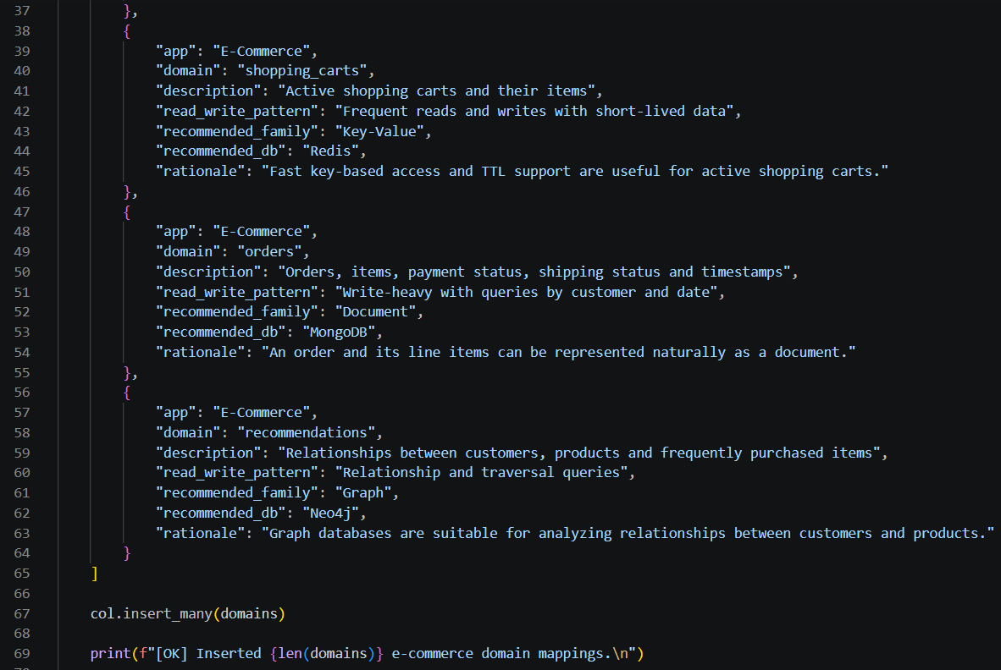
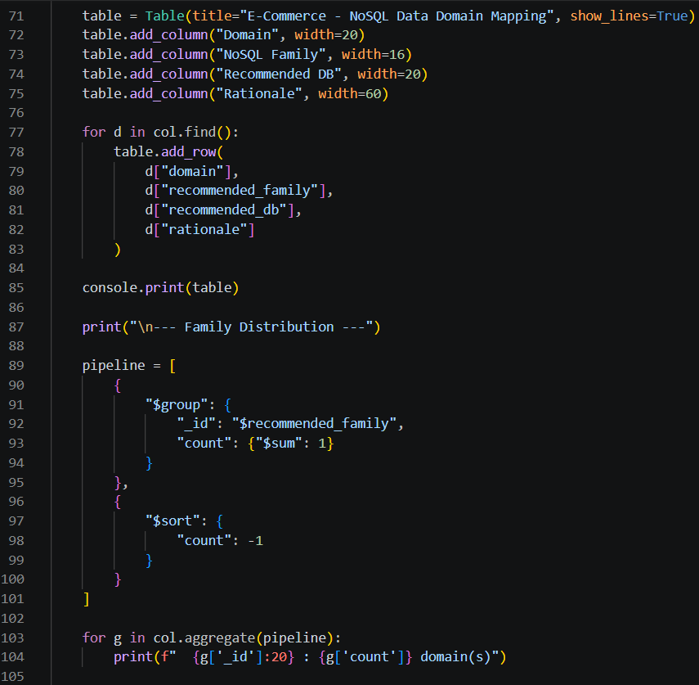
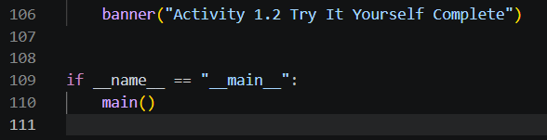

Output:
